**IT5016: Software Development Fundamentals**

**Assessment 1: Flow chart and pseudo-code**

**NAME : PRAJAPATI VRAJ KALPESHKUMAR**

**STUDENT ID : 20240661**

* **Overview :**

There are several usage of Flowchart and pseudocode, hence, I represented recipe of Cookies with the help of two Basic and indispensable techniques, pseudocode, Flowchart as well.

* **Flowchart :-**

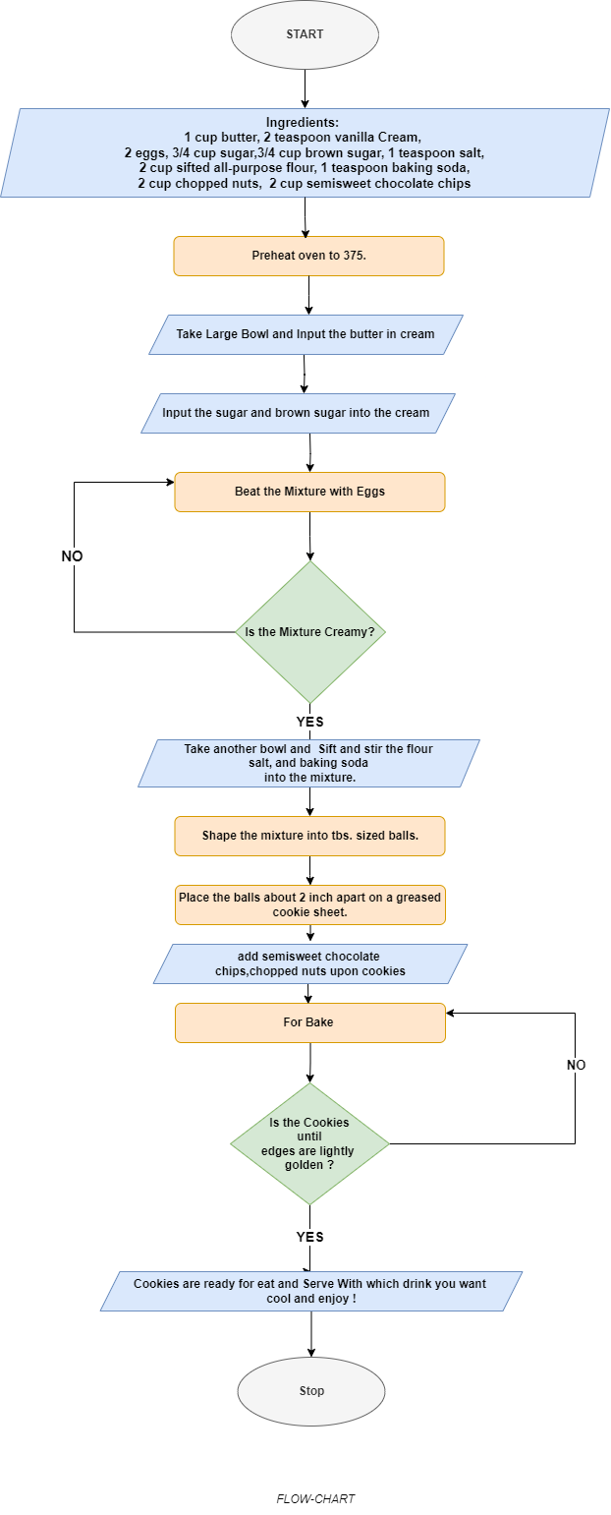

* **PSEUDOCODE : -**

PROCEDURE Make Cookies

// Ingredients

    2 cups of all-purpose flour

    1 tsp baking soda

    1 tsp salt

    1 cup unsalted butter, at room temperature

    3/4 cup white granulated sugar

    3/4 cup brown sugar

    2 large eggs

    2 teaspoons vanilla extract

    2 cups semi-sweet chocolate chips

// Preheat oven

    PREHEAT Oven TO 370-375°F

    Preheat oven for 10 minutes

// Mix dry ingredients

    MIX butter, Vanila cream, sugar,brownsugar UNTIL light AND fluffy

// beat in

    ADD eggs, MIXING WELL AFTER EACH ADDITION

// Mix dry ingredients

  MIX flour, baking Powder, AND salt IN SEPARATE BOWL

// Combine wet and dry ingredients

  COMBINE wet AND dry ingredients, MIXING UNTIL JUST COMBINED

// Add chocolate chips

  FOLD IN chocolate Chips

// Scoop cookies

  SCOOP tablespoon-SIZED BALLS OF DOUGH ONTO baking Sheet, LEAVING 2 inches

  OF SPACE BETWEEN EACH COOKIE

// Bake cookies

  BAKE FOR FEW minutes, OR UNTIL LIGHTLY GOLDEN

// Cool cookies

  COOL ON baking Sheet FEW minutes, THEN TRANSFER TO Wire Rack TO COOL COMPLETELY

// Enjoy with your Cookies

    Serve with Which drink you want!